№1

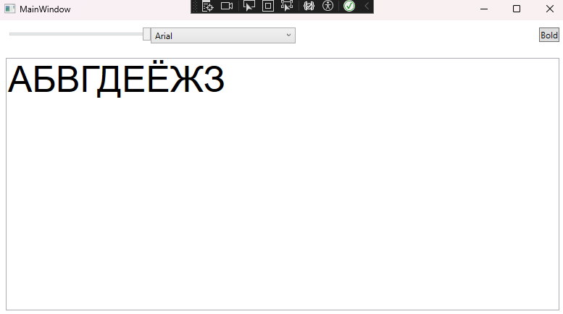

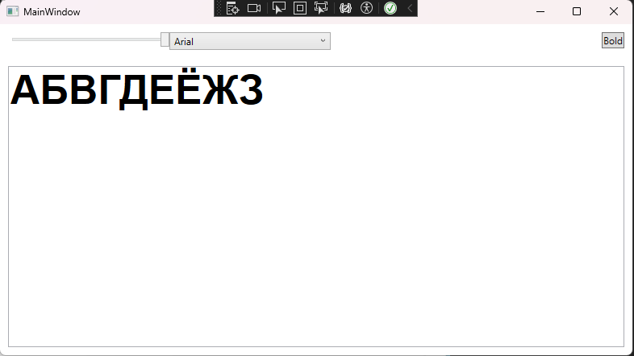

MainWindow.xaml  
  
<Window x:Class="WpfApp5.MainWindow"

xmlns="http://schemas.microsoft.com/winfx/2006/xaml/presentation"

xmlns:x="http://schemas.microsoft.com/winfx/2006/xaml"

xmlns:d="http://schemas.microsoft.com/expression/blend/2008"

xmlns:mc="http://schemas.openxmlformats.org/markup-compatibility/2006"

xmlns:local="clr-namespace:WpfApp5"

mc:Ignorable="d"

Title="MainWindow" Height="450" Width="800">

<Grid>

<Grid.RowDefinitions>

<RowDefinition Height="Auto"/>

<RowDefinition Height="*"/>

</Grid.RowDefinitions>

<StackPanel Grid.Row="0" Orientation="Horizontal" Margin="10">

<Slider x:Name="fontSizeSlider" Width="200" Minimum="10" Maximum="50" Value="20" ValueChanged="FontSizeSlider_ValueChanged"/>

<ComboBox x:Name="fontComboBox" Width="200" VerticalAlignment="Center" SelectionChanged="fontComboBox_SelectionChanged"/>

</StackPanel>

<TextBox x:Name="textBox" Grid.Row="1" AcceptsReturn="True" Margin="10"/>

<Button Content="Bold" HorizontalAlignment="Right" VerticalAlignment="Top" Margin="10" Click="BoldButton_Click"/>

</Grid>

</Window>

MainWindow.xaml.cs

using System;

using System.Collections.Generic;

using System.Linq;

using System.Text;

using System.Threading.Tasks;

using System.Windows;

using System.Windows.Controls;

using System.Windows.Data;

using System.Windows.Documents;

using System.Windows.Input;

using System.Windows.Media;

using System.Windows.Media.Imaging;

using System.Windows.Navigation;

using System.Windows.Shapes;

namespace WpfApp5

{

public partial class MainWindow : Window

{

public MainWindow()

{

InitializeComponent();

foreach (FontFamily fontFamily in Fonts.SystemFontFamilies)

{

fontComboBox.Items.Add(fontFamily.Source);

}

}

private void FontSizeSlider_ValueChanged(object sender, RoutedPropertyChangedEventArgs<double> e)

{

if (textBox != null)

{

textBox.FontSize = e.NewValue;

}

}

private void fontComboBox_SelectionChanged(object sender, SelectionChangedEventArgs e)

{

if (fontComboBox != null && fontComboBox.SelectedItem != null && textBox != null)

{

string selectedFont = fontComboBox.SelectedItem.ToString();

textBox.FontFamily = new FontFamily(selectedFont);

}

}

private void BoldButton_Click(object sender, RoutedEventArgs e)

{

if (textBox != null)

{

textBox.FontWeight = (textBox.FontWeight == FontWeights.Bold) ? FontWeights.Normal : FontWeights.Bold;

}

}

}

}

№2  
  
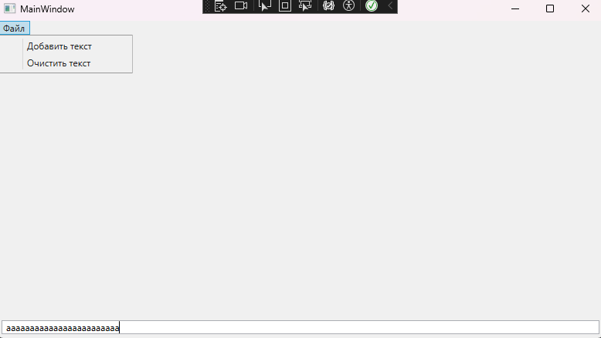

MainWindow.xaml

<Window x:Class="WpfApp6.MainWindow"

xmlns="http://schemas.microsoft.com/winfx/2006/xaml/presentation"

xmlns:x="http://schemas.microsoft.com/winfx/2006/xaml"

xmlns:d="http://schemas.microsoft.com/expression/blend/2008"

xmlns:mc="http://schemas.openxmlformats.org/markup-compatibility/2006"

xmlns:local="clr-namespace:WpfApp6"

mc:Ignorable="d"

Title="MainWindow" Height="450" Width="800">

<Grid>

<Menu>

<MenuItem Header="Файл">

<MenuItem Header="Добавить текст" Click="AddText_Click"/>

<MenuItem Header="Очистить текст" Click="ClearText_Click"/>

</MenuItem>

</Menu>

<RichTextBox Name="richTextBox" VerticalAlignment="Bottom" HorizontalAlignment="Stretch" Margin="5"/>

</Grid>

</Window>

MainWindow.xaml.cs  
  
using System;

using System.Collections.Generic;

using System.Linq;

using System.Text;

using System.Threading.Tasks;

using System.Windows;

using System.Windows.Controls;

using System.Windows.Data;

using System.Windows.Documents;

using System.Windows.Input;

using System.Windows.Media;

using System.Windows.Media.Imaging;

using System.Windows.Navigation;

using System.Windows.Shapes;

namespace WpfApp6

{

public partial class MainWindow : Window

{

public MainWindow()

{

InitializeComponent();

}

private void AddText_Click(object sender, RoutedEventArgs e)

{

richTextBox.AppendText("Новый текст\n");

}

private void ClearText_Click(object sender, RoutedEventArgs e)

{

richTextBox.Document.Blocks.Clear();

}

private void richTextBox_TextChanged(object sender, TextChangedEventArgs e)

{

}

}

}  
  
  
  
  
ЗАДАНИЕ 23.11.2023  
  
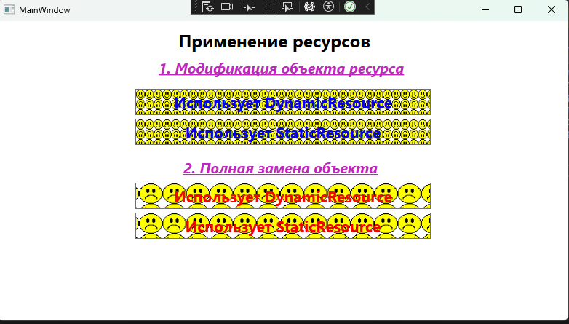

MainWindow.xaml

<Window x:Class="WpfApp2.MainWindow"

xmlns="http://schemas.microsoft.com/winfx/2006/xaml/presentation"

xmlns:x="http://schemas.microsoft.com/winfx/2006/xaml"

xmlns:d="http://schemas.microsoft.com/expression/blend/2008"

xmlns:mc="http://schemas.openxmlformats.org/markup-compatibility/2006"

xmlns:local="clr-namespace:WpfApp2"

mc:Ignorable="d"

Title="MainWindow" Height="450" Width="800">

<Grid HorizontalAlignment="Center">

<TextBlock HorizontalAlignment="Center" Margin="0,10,0,0" TextWrapping="Wrap" VerticalAlignment="Top" FontSize="24" FontWeight="Bold" Height="32" Width="288">

Применение ресурсов

</TextBlock>

<TextBlock HorizontalAlignment="Center" Margin="0,50,0,0" TextWrapping="Wrap" Text="1. Модификация объекта ресурса" VerticalAlignment="Top" Foreground="#FFC126C1" FontStyle="Italic" FontWeight="Bold" TextDecorations="Underline" FontSize="20" Height="27" Width="342" />

<Button Content="Использует DynamicResource" FontSize="21" HorizontalAlignment="Center" Margin="0,93,0,0" VerticalAlignment="Top" Height="36" Width="406" Background="{DynamicResource DynamicBrush1}" Click="Button_Click" Foreground="#FF0400F3" FontWeight="Bold"/>

<Button Content="Использует StaticResource" FontSize="21" HorizontalAlignment="Center" Margin="0,134,0,0" VerticalAlignment="Top" Height="36" Width="406" Background="{StaticResource StaticBrush1}" Click="Button_Click" Foreground="#FF0400F3" FontWeight="Bold"/>

<TextBlock HorizontalAlignment="Center" Margin="0,187,0,0" TextWrapping="Wrap" Text="2. Полная замена объекта ресурса" VerticalAlignment="Top" Foreground="#FFC126C1" FontStyle="Italic" FontWeight="Bold" TextDecorations="Underline" FontSize="20" Height="27" Width="274"/>

<Button Content="Использует DynamicResource" FontSize="21" HorizontalAlignment="Center" Margin="0,222,0,0" VerticalAlignment="Top" Height="36" Width="406" Background="{DynamicResource DynamicBrush2}" Click="Button_Click" Foreground="#FFF30700" FontWeight="Bold"/>

<Button Content="Использует StaticResource" FontSize="21" HorizontalAlignment="Center" Margin="0,263,0,0" VerticalAlignment="Top" Height="36" Width="406" Background="{StaticResource StaticBrush2}" Click="Button_Click" Foreground="#FFF30000" FontWeight="Bold"/>

</Grid>

</Window>